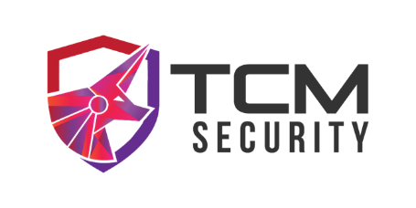

DEMO CORP
Security Assessment Findings Report

Business Confidential

Date: March 9th, 2021 Project: DC-001 Version 1.0



Table of Contents

Table of Contents
Business Confidential 1
Table of Contents 2
Confidentiality Statement 4
Disclaimer 4
Contact Information 4
Assessment Overview 5
Assessment Components 5
Internal Penetration Test 5
Finding Severity Ratings 6
Risk Factors 6
Likelihood 6
Impact 6
Scope 7
Scope Exclusions 7
Client Allowances 7
Executive Summary 8
Scoping and Time Limitations 8
Testing Summary 8
Tester Notes and Recommendations 9
Key Strengths and Weaknesses 10
Vulnerability Summary & Report Card 11
Internal Penetration Test Findings 11
Technical Findings 12
Internal Penetration Test Findings 12
Additional Scans and Reports 13

Confidentiality Statement
This document is the exclusive property of Demo Corp and TCM Security (TCMS). This document contains proprietary and confidential information. Duplication, redistribution, or use, in whole or in part, in any form, requires consent of both Demo Corp and TCMS.
Demo Corp may share this document with auditors under non-disclosure agreements to demonstrate penetration test requirement compliance.

Disclaimer
A penetration test is considered a snapshot in time. The findings and recommendations reflect the information gathered during the assessment and not any changes or modifications made outside of that period.
Time-limited engagements do not allow for a full evaluation of all security controls. TCMS prioritized the assessment to identify the weakest security controls an attacker would exploit. TCMS recommends conducting similar assessments on an annual basis by internal or third-party assessors to ensure the continued success of the controls.

Contact Information

Name | Title | Contact Information
Demo Corp
John Smith | Global Information Security Manager | Email: jsmith@democorp.com
TCM Security
Heath Adams | Lead Penetration Tester | Email: heath@tcm-sec.com

Assessment Overview
From February 22nd, 2021 to March 5th, 2021, Demo Corp engaged TCMS to evaluate the security posture of its infrastructure compared to current industry best practices that included an internal network penetration test. All testing performed is based on the NIST SP 800-115 Technical Guide to Information Security Testing and Assessment, OWASP Testing Guide (v4), and customized testing frameworks.
Phases of penetration testing activities include the following:
- Planning – Customer goals are gathered and rules of engagement obtained.
- Discovery – Perform scanning and enumeration to identify potential vulnerabilities, weak areas, and exploits.
- Attack – Confirm potential vulnerabilities through exploitation and perform additional discovery upon new access.
- Reporting – Document all found vulnerabilities and exploits, failed attempts, and company strengths and weaknesses.
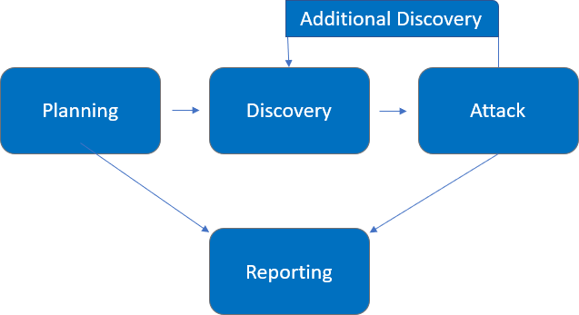

Assessment Components

API Penetration Test
This API penetration test simulated real-world attackers targeting your application programming interfaces (APIs) and their supporting infrastructure. Testers performed comprehensive discovery and both automated and manual testing to identify and validate issues such as broken object-level access control (BOLA/IDOR), authentication and authorization weaknesses (including JWT / OAuth misconfigurations), injection flaws, insecure deserialization, XML external entity (XXE) and SSRF vulnerabilities, excessive data exposure, rate-limit and rate-limit bypass issues, and insecure configuration. Confirmed vulnerabilities were safely exploited where appropriate to demonstrate potential impact—such as unauthorized access to user data, privilege escalation, business-logic abuse, and data exfiltration. Findings are prioritized by risk and include clear, actionable remediation guidance to reduce exposure and protect sensitive data and services.

Finding Severity Ratings
The following table defines levels of severity and corresponding CVSS score range that are used throughout the document to assess vulnerability and risk impact.

Severity | CVSS V3  Score Range | Definition
Critical | 9.0-10.0 | Exploitation is straightforward and usually results in system-level compromise. It is advised to form a plan of action and patch immediately.
High | 7.0-8.9 | Exploitation is more difficult but could cause elevated privileges and potentially a loss of data or downtime. It is advised to form a plan of action and patch as soon as possible.
Moderate | 4.0-6.9 | Vulnerabilities exist but are not exploitable or require extra steps such as social engineering. It is advised to form a plan of action and patch after high-priority issues have been resolved.
Low | 0.1-3.9 | Vulnerabilities are non-exploitable but would reduce an organization’s attack surface. It is advised to form a plan of action and patch during the next maintenance window.
Informational | N/A | No vulnerability exists. Additional information is provided regarding items noticed during testing, strong controls, and additional documentation.

Risk Factors
Risk is measured by two factors: Likelihood and Impact:

Likelihood
Likelihood measures the potential of a vulnerability being exploited. Ratings are given based on the difficulty of the attack, the available tools, attacker skill level, and client environment.

Impact
Impact measures the potential vulnerability’s effect on operations, including confidentiality, integrity, and availability of client systems and/or data, reputational harm, and financial loss.

Scope

Assessment | Details
Web Penetration Test | http://www.demo.com/api/

Scope Exclusions
Per client request, TCMS did not perform any of the following attacks during testing:
- Denial of Service (DoS)
- Phishing/Social Engineering

All other attacks not specified above were permitted by Demo Corp.

Client Allowances
Demo Corp provided TCMS the following allowances:

- Internal access to network via dropbox and port allowances

Executive Summary
TCMS evaluated Demo Corp’s internal security posture through penetration testing from February 22nd, 2021 to March 5th, 2021. The following sections provide a high-level overview of vulnerabilities discovered, successful and unsuccessful attempts, and strengths and weaknesses.

Scoping and Time Limitations
Scoping during the engagement did not permit denial of service or social engineering across all testing components.

Time limitations were in place for testing. Internal network penetration testing was permitted for ten
- business days.

Testing Summary
The The API penetration test evaluated Demo Corp’s application programming interfaces (APIs) to assess their overall security posture and identify weaknesses that could lead to unauthorized access or data exposure. The TCMS team conducted both authenticated and unauthenticated testing across all in-scope endpoints using a combination of automated tools and manual testing techniques. The goal was to uncover vulnerabilities affecting authentication, authorization, input validation, business logic, and API configuration.
During testing, the TCMS team identified several endpoints that lacked proper authorization enforcement (Finding API-001), allowing unauthorized users to access or modify other users’ data. This issue demonstrated a broken object-level access control (BOLA) vulnerability, which can lead to sensitive information disclosure. Weaknesses were also found in the authentication mechanisms (Finding API-003), where insufficient validation of JSON Web Tokens (JWT) allowed token replay and privilege escalation. In addition, missing token expiration and revocation controls (Finding API-004) increased the risk of unauthorized session reuse.
By chaining these weaknesses, the TCMS team successfully impersonated legitimate users and accessed restricted API resources containing sensitive customer and system data. Several endpoints were also observed to disclose excessive information in their responses (Finding API-005), including internal identifiers, password hashes, and debugging details. Further testing revealed injection vulnerabilities (Finding API-006) that enabled SQL and NoSQL injection, leading to unauthorized data extraction from the backend database. A misconfigured API gateway (Finding API-008) lacking rate-limiting and request filtering also allowed brute-force and enumeration attacks.
Through the exploitation of these issues, the TCMS team was able to escalate privileges from a standard user account to administrative access within the API management console. Using this elevated access, the team obtained valid service credentials that provided full read and write permissions to the production database via the API layer, resulting in complete data compromise (see Finding API-015 for the full exploitation chain).

Additional issues were identified during the assessment, including exposed internal endpoints intended for development or debugging (Finding API-009) that revealed environment variables and database connection details. The team also found overly permissive Cross-Origin Resource Sharing (CORS) configurations (Finding API-010) that allowed requests from any origin, potentially enabling cross-site data exfiltration. Several outdated backend components were detected (Findings API-011 through API-014) containing known vulnerabilities such as remote code execution and insecure deserialization, which could allow attackers to execute arbitrary code or escalate privileges on the underlying system.
The remaining findings were categorized as high, moderate, low, or informational severity. For detailed descriptions, technical evidence, and remediation recommendations, please refer to the Technical Findings section of this report.

Tester Notes and Recommendations

Based on the results of an examination by our Team, vulnerabilities were found in the XXX web application which can be exploited and displays sensitive information and data which can be used by attackers to study, infiltrate and take over the web server. For this reason, we recommend that you do:
- Implement parameterized statements (Prepared Statements): Use prepared statements with bound parameters to ensure that user input is treated as data, not executable code.
- Validate and sanitize all user inputs: Perform strict input validation on both client-side and server-side to ensure only expected data formats are accepted.
- Implement escaping mechanisms: Escape special characters in user input to prevent malicious SQL queries from being executed.
- Use stored procedures: Where applicable, use stored procedures with proper input validation to reduce the risk of SQL Injection.
- Disable error messages that expose sensitive information: Avoid displaying detailed database errors to users, as they can provide attackers with valuable insights into the database structure.
Regularly update and patch database systems: Ensure that all database software and libraries are up-to-date to address known vulnerabilities.

Key Strengths and Weaknesses
The following identifies the key strengths identified during the assessment:

  - Observed some scanning of common enumeration tools (Nessus)
  - Mimikatz detected on some machines
  - Service accounts were not running as domain administrators
  - Demo Corp local administrator account password was unique to each device The following identifies the key weaknesses identified during the assessment:
- Password policy found to be insufficient

Vulnerability Summary & Report Card
The following tables illustrate the vulnerabilities found by impact and recommended remediations:

Internal Penetration Test Findings

13 | 5 | 6 | 0 | 1
Critical | High | Moderate | Low | Informational

Finding | Severity | Recommendation
Internal Penetration Test
IPT-001: Insufficient LLMNR Configuration | Critical | Disable multicast name resolution via GPO.

Technical Findings

Web Penetration Test Findings
Finding WPT-001: Insufficient LLMNR Configuration (Critical)
URL: |  | Feature:
Description:
Impact:
Severity: |  |  |  | Impact:
CVSS Base Score: |  |  |  | CWE:
Score Vector:
Recommendation:
References:

Evidence
Figure 1: Captured hash of “production”

Remediation
Figure 2: Cracked hash of “production”

Disable multicast name resolution via GPO. For full mitigation and detection guidance, please reference the MITRE guidance here.
The cracked hashes demonstrate a deficient password complexity policy. If multicast name resolution is required, Network Access Control (NAC) combined with application whitelisting can limit these attacks.

Additional Scans and Reports
TCMS provides all clients with all report information gathered during testing. This includes Nessus files and full vulnerability scans in detailed formats. These reports contain raw vulnerability scans and additional vulnerabilities not exploited by TCM Security.

The reports identify hygiene issues needing attention but are less likely to lead to a breach, i.e. defense-in-depth opportunities. For more information, please see the documents in your shared drive folder labeled “Additional Scans and Reports”.

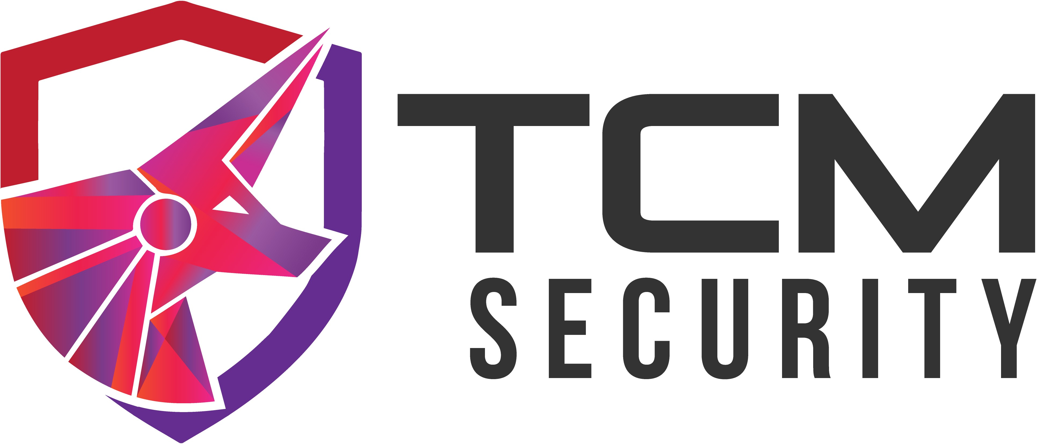

Last Page

